**HW#6 Discrimination and Classification _ 201511646 나여영**

**1. The following data were recorded for two species of irises. The objective is to develop a rule for classifying a new flower based on the four variables sl (Sepal Length), sw (Sepal Width), pl (Petal Length), pw (Petal Width).**

**Provide necessary computer output to solve the following problems 1) and 2).**

R에 내장되어 있는 Iris 데이터를 재구성하여 문제와 같이 복원했다.

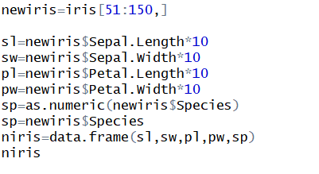

1. Develop such a rule using the proc discrim. Try linear and quadratic discriminant functions

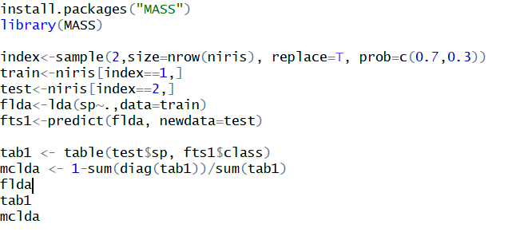

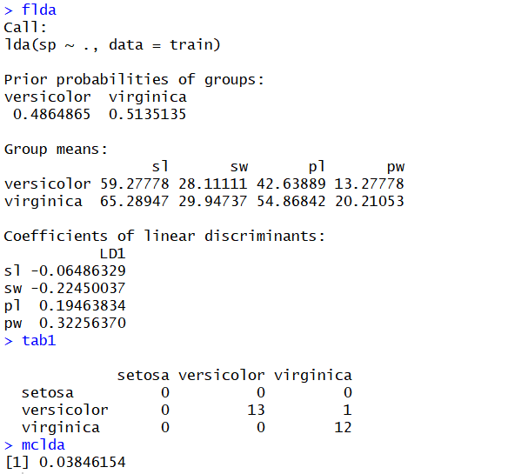

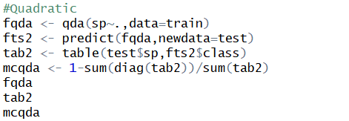

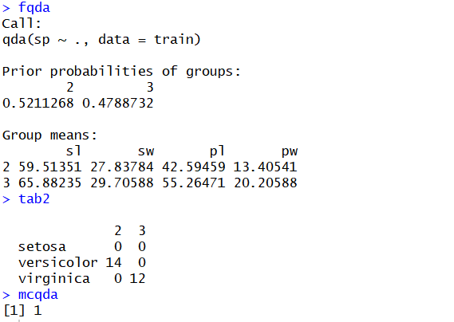

1. **A new iris is discovered use your results to classify the new species into one of these two groups. The new data are sl=60, sw=25, pl=40, pw=11. Use linear discriminant functions with c(1|2)=c(2|1) and P1=P2.**



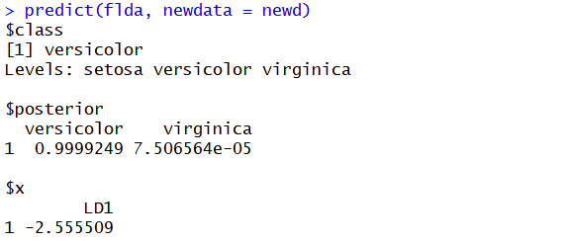

**2. Show that**

DRW00000d44435b